*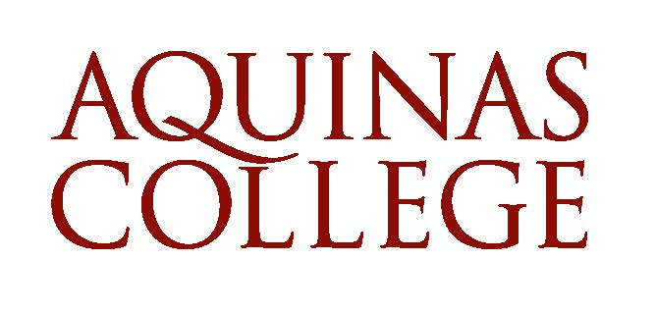*

*Laudato Si’* Reflection Statement

August 2, 2024

“In the beginning was the Word, and the Word was with God, and the Word was God” (John 1:1). From this Word, Earth and human existence were created. As far as we can tell, the great universe in all of its expanse sustains just one planet upon which we humans can live, thrive, and share in creation; this of course is Earth, or perhaps better said, our common home.

We see the world with certain divisions, caused by humans, and we also hear the cry of the poor and the crying out of our planet. With hearts geared towards service and inspired by the call in Genesis to tend and keep the garden, we strive for our everyday lives to become acts of service, understanding how, within our one common home, everyone is our neighbor and everywhere is our home.

Our collective human vocation is to know God, to revel in His glory, and to tend this garden for the sake of the life-sustaining ability of the planet and for all persons living on this globe to truly thrive. We speak of this desired approach to living out our human vocation as 'integral ecology.' However, within humanity, there is an abundance of failure in fulfilling this vocation, as evidenced by the too-long history of wars, murder, abuse of others, and the unchecked and immoral destruction and degradation of the natural environment.

*Laudato Si’* is a profound reflection on the interconnectedness of environmental, social, and spiritual concerns. It calls for urgent global action to address environmental degradation, climate change, as well as social inequality, emphasizing the need for an integral ecology that respects both the environment and human dignity, especially in the case of the poor and most marginalized. In this encyclical, Pope Francis invites individuals, communities (including Colleges and Universities), and nations to adopt responsible stewardship of the Earth, fostering a holistic approach to caring for our common home and its inhabitants. After all, “all things were created through him and for him” (Colossians 1:16).

St. Thomas Aquinas, our namesake and patron, offers a substantial understanding of creation and the nature of the human person. All that exists is the gift of God extending Himself outward out of love with the intended result of creation returning to God in love. We humans are a marvelous expression of creation, composed of matter and form, that is both body and soul. We are invited to remain in the world as ambassadors of God’s love. “I do not ask that you take them out of this world, but that you keep them from the evil one…as you sent Me into the world, so I sent them into the world” (John 17:15, 18). We are called not to escape this world but to revel in God’s Garden.

Aquinas College, established by the Dominican Sisters of Grand Rapids more than 125 years ago, has a rich spiritual and ecological history that unveils a profound connection between the institution’s core values, reflected in the Dominican Pillars of prayer, study, community, and service, as well as a deep investment in Catholic Social Teaching– all of which are intricately tied to the *Laudato Si’* Action Platform.

The Center for Sustainability at Aquinas College, founded in 2005 to lead the college’s sustainability efforts, has laid a solid foundation for both living sustainably and facilitating the creation of an organization grounded in the triple bottom line. The Center has enhanced the College's efforts to align with LEED certification, approach zero-waste status, protect the urban forest, and create a community garden. Yet more can be done to connect these important sustainable life skills to the hearts of our community and to integrate the principles of restoration, social justice, and caring for the most vulnerable into our work.

 Aquinas College leadership and the dedicated *Laudato Si’* Action Platform Steering Committee agree now is our time to be a guiding influence for our students,  our collegiate community, and the surrounding Grand Rapids community, regarding how to live in a more just, sustainable, and responsible way in caring for our common home.

The Laudato Si' Action Platform is an opportune moment for Aquinas College to enact, with greater focus and energy, the integral ecology of human flourishing with best practices for sustaining the global environment. We have the fundamental spiritual and theological pieces for such a life-changing effort. With joy, we apply these principles with the grace given by our Creator.