**“Pilgrims of Hope who went on a Journey for Life and Peace”**

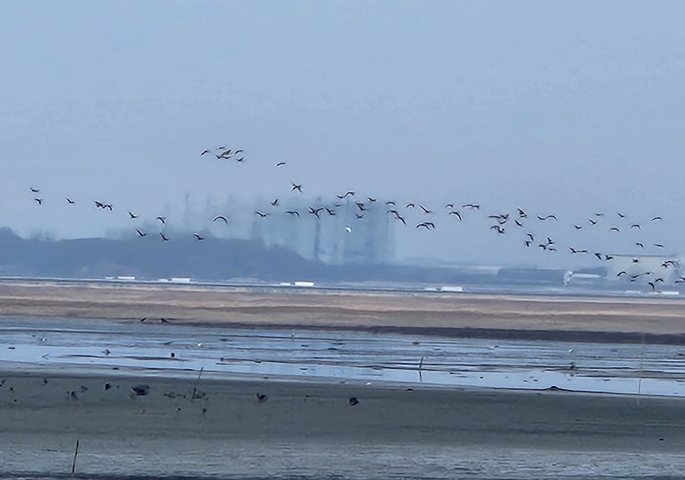On Jan. 20, 2025, the sisters of Regina Pacis Province journeyed to Saemangeum Gaetbol/a tidal flat, one of the areas currently suffering the most in Korea. Located on the west coast of Korea, Saemangeum Gaetbol is one of the world’s five major tidal flats, a precious land that purifies and restores the earth in pain.

Hearing the cries of this land, especially notably the cries of sea creatures in this tidal flat, we, the sisters embarked on a pilgrimage to this place of lament “as pilgrims of hope on a journey for life and peace.”

The Saemangeum development project, which began in 1987 with the promise of turning the tidal flat into fertile agricultural land to gain public support was driven by political motivations, causing immense pain and endangering countless species. The embankment, which is 33 km long, became the longest bridge in the world and blocked water from the tidal flat, causing deaths of multiple marine species. As delegates for those whose lives have been in crisis for the past 30 years, activists and a civil watchdog have called for ‘the constant circulation of seawater at Saemanguem’ on a daily basis, which led to the opening of the sluice gate, though not continuously.

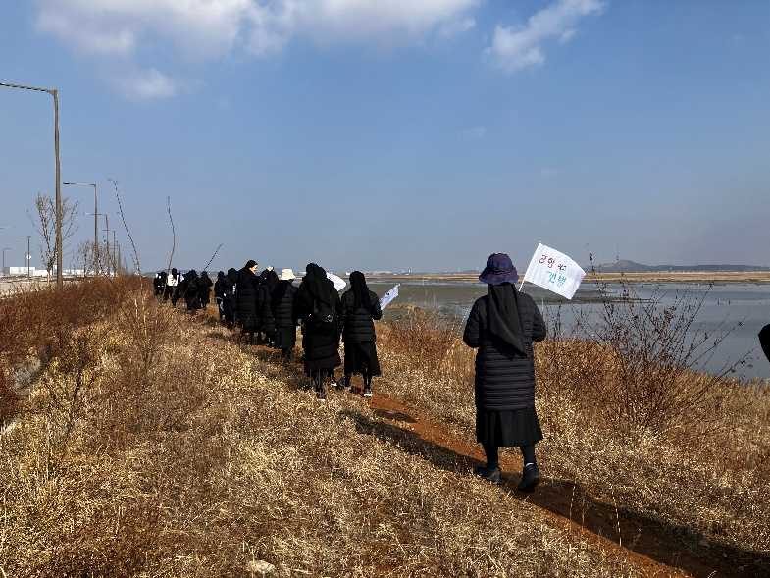In Saemangeum, there is still a living tidal flat called ‘Sura Gaetbol.’ ‘Sura’ means that it is as beautiful as an embroidered silk cloth.’ However, on this beautiful flat, the only remaining Gaetbol, they plan to build an international airport, expanding the US military base. It is said that the tragic plane crash at Muan International Airport near Saemangeum on Dec. 29, 2024, was partly caused by migratory birds. According to environmental effect evaluations, Korea’s west coast tidal flats are unsuitable for an airport as they serve as crucial stopover points for migratory birds during their long journeys. Despite this, the new airport construction project is underway on the Saemangeum Gaetbol, a vital habitat for these birds. With the risk of bird strikes by planes being 610 times higher than at Muan International Airport, activists and the civil watchdog are advocating to protect numerous endangered lives.

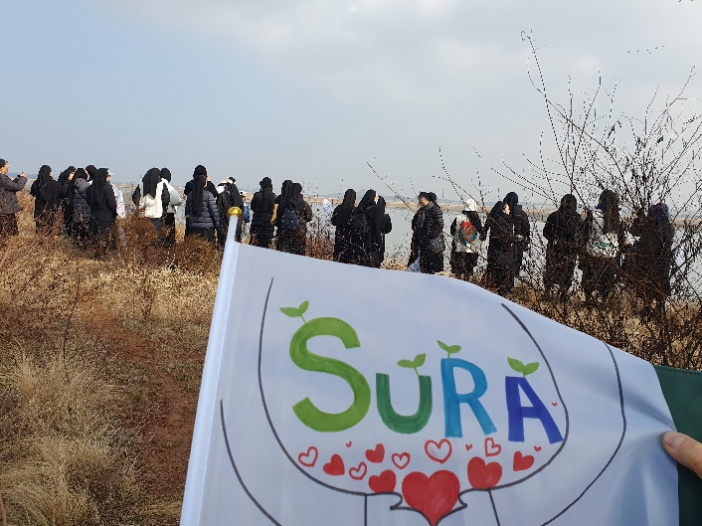JPIC Committee of Sisters of Notre Dame in Korea planned the Laudato Si Action Platform and organized a ‘pilgrimage of life and peace’ to ‘Sura Gaetbol’ for the sisters of the province to listen attentively to the earth’s cry.’ 42 sisters gathered from all over the country along with five children from sisters’ ministry locations.

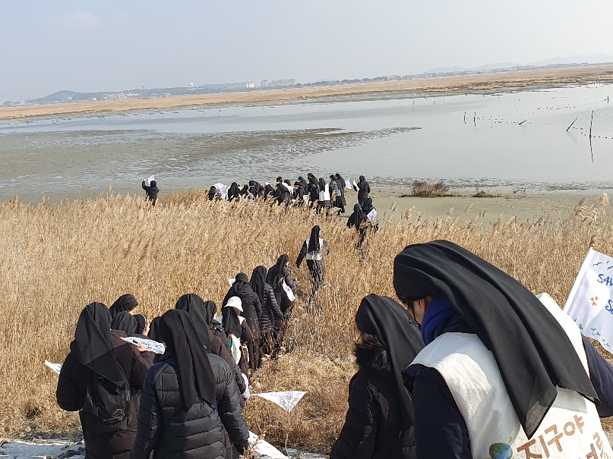Holding a banner that read “Sura is still alive,” we encountered Sura’s life and witnessed that the mudflats and the ecosystem dependent on them were still alive, waiting for the sea waters to reenter after being blocked by humans for a decade. Marine wildlife is naturally meant to meet seawater twice a day, but human greed has decimated a large portion of it. Therefore, we prayed for the circulation of seawater and the restoration of the ecosystem and attended a Mass, which was celebrated for these intentions.

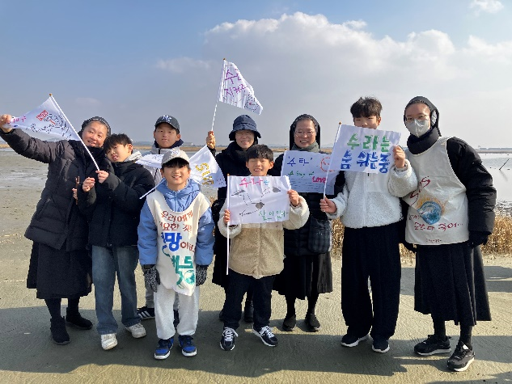Under the guidance of Oh Dong-Pil who is involved in the Saemanguem civil watchdog, we heard stories of many lives dependent on Gaetbol including birds, water deer, various kinds of shells, salt plants and many more. By observing the traces left by these precious creatures, we expressed our gratitude for all lives connected to us and felt a deep love for them. As we walked at their pace, seeing and being with them in their habitat, we recalled the mission God gave us, “go out to the whole world, proclaim the gospel to all creation.”(Mar. 16,15).” We placed ‘hope’ in our footsteps, paying attention to all of creation there and its voice. Even its cries we found beautiful, as we strived to become footsteps that bring good news. We walked in the way the whole tidal flat land could feel it and all the tiny organisms, shrimps, crabs, shells, birds and other lives could recognize our steps as ‘hope.’

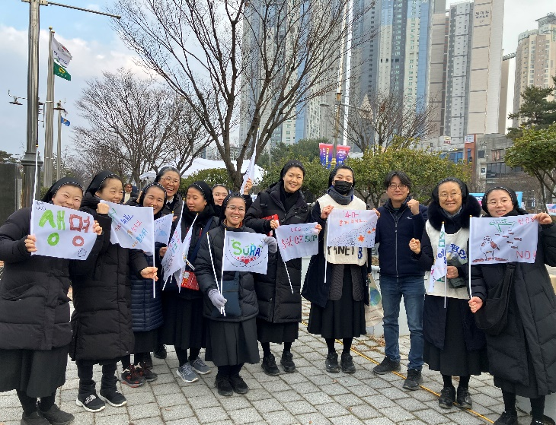Mr. Oh of the civil watchdog said that because of “the sin of having witnessed such beauty,” he could not help but be with them. That day we also joined in “his sin of experiencing such beauty” and promised to advocate for their dignity, grateful for their existence.

When we approached the habitat of migratory birds, we whistled first to signal our presence, so as not to startle them, then literally asked them if we might come closer and waited to give them time, allowing them gradually to move away. It was an incredibly holy moment. We were inspired by the beautiful Gaetbol which spread so expansively before us. It was a time when we thanked the creation for its silent patience with humanity’s reckless choices and offered apologies for the harm caused.

As Jeon-ju diocese celebrates a weekly Mass in front us the provincial government building for ‘Constant circulation of seawater in Saemangeum and the restoration of ecosystem,’ we attended this Mass. Priests of the diocese and the faithful gathered for it. Despite the cold weather, the Mass on the street felt warm and was filled with abundant hope.

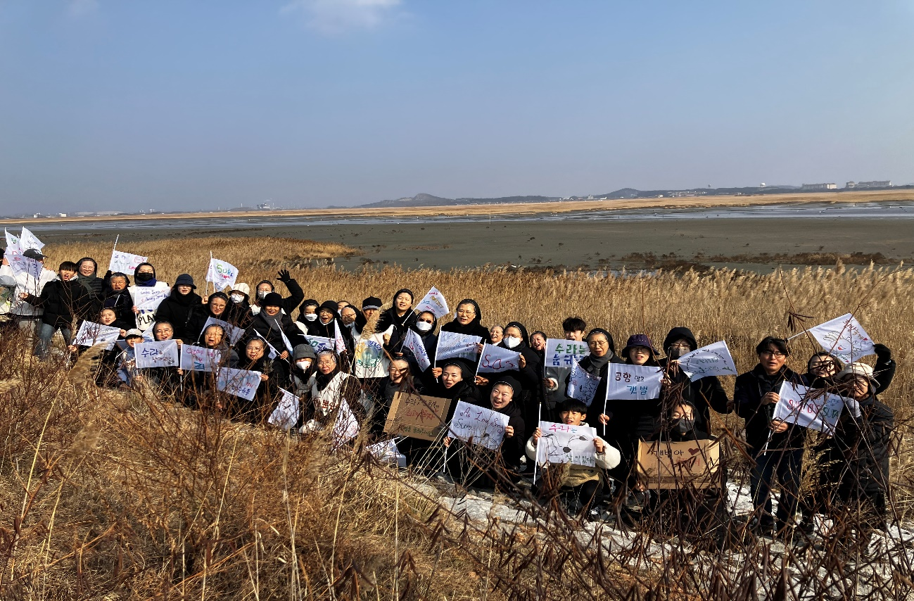As “pilgrims who went on a journey for life and peace,” we listened to the cry of our Earth, felt with our whole body and mind the dignity of lives created by God and marveled at the truth that we all belong to God’s creation, alongside all these lives. Following this pilgrimage, the sisters running various institutes are preparing engaging activities that will enable children and collaborators to take part in the pilgrim journey of visiting the lives in ‘Sura Gaetbol.’

